August 26, 2020

Dear Members of the House Ways & Means CARES Act Ad Hoc Committee,
On behalf of the Riverbanks Park District, I respectfully request that you provide state emergency funding to Riverbanks Zoo and Garden as soon as possible due to the devastating impact of COVID-19. Riverbanks Zoo and Gardens emergency savings account is being depleted fast and will be out of operational fund dollars within the next 60 days. These funds are used to employee our animal care staff and to feed and care for our collection of animals, some of which are highly endangered species.
Riverbanks does not qualify for funding from the CARES Act including the option to borrow money from lending institutions due to our 501c1 governmental status.
We are exploring every option for funding and are working around the clock soliciting donations for care of our animals and staff but need some assurance that you will be able to provide assistance in order to sustain the care and welfare of the Zoo’s collection.
Expenses associated with the care of our animal and plant collections average $1 million per month regardless of whether we are open to the public or not. The following shows the losses incurred during the closure and continue to impact revenues needed while on limited attendance restrictions as set by the Governor and CDC.
Month | Days Closed | Loss Attendance | Loss Revenue | Total Expense While Closed
March | 16 | 69,159 | $725,584 | $765,714
April | 30 | 174,000 | $1,854,993 | $961,362
May | 21 | 152,000 | $1,536,800 | $950,000
Total | 67 | 395,159 | $4,117,377 | $2,677,076

More than 80% of Riverbanks Zoo and Garden's revenue is generated by members and tourists and historically, spring crowds visiting March – June generate more than 37% of our annual revenue. Research show that Riverbanks annual economic impact exceeds $140M and supports over 1,800 local jobs by hosting 1.2 million visitors in annually.

Consequently, extended closure during peak season is having a dramatic impact on our overall operations and forced a significant workforce reduction. During the two months we were closed, we suffered a loss of more than $4 million in operating revenue and over 300 employees, and our educational programming and special events had to be cancelled.
Despite the challenges, our dedicated essential staff continues to provide the highest quality care to our visitors by requiring masks, regulating the flow of visitors, requiring advance and timed ticket reservations and the continue safe practices of sanitizing all areas constantly per CDC recommendations. In conjunction, we have not sacrificed the well-being and care of the animals and plants, continue to engage our community in new ways, and provide online educational and inspirational videos to those who are not able to visit in person.
With emergency funding assistance, Riverbanks Zoo and Garden can continue to be a place of wonderment for all ages--a place where individuals and families can get outdoors and connect with nature, a trusted conservation resource, and a destination that attracts and engages visitors, strengthens our local economy and enhances the quality of life in our community and state.
Please consider the value of Riverbanks Zoo and Garden as a state treasure and answer our call for help.
Respectfully yours,
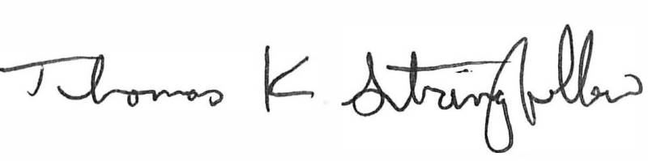
Tommy Stringfellow
President & CEO

